Milestone timelines
A conference timeline visually presents major milestones before, during, and after the conference. Once you’ve identified a conference you plan on attending, it is best to create a timeline as soon as possible to ensure nothing falls through the cracks. One strategy to consider is to start with a milestone checklist for initial conference-related information extraction. Entries in the checklist can then be translated to a timeline format for easier visualization. An example checklist is as follows:

Milestone checklist
- Travel logistics
  - Funding support for conference registration fees and the below logistics
  - Getting to the conference
  - Getting around the conference
  - Lodging at the conference
- Goal definition
  - Network with potential collaborators
  - Get a sense of the state of the art in xyz topic
  - Invite experts to your oral or poster presentation
- Presentation preparation
  - Determine formatting requirements for your presentation type
  - Coordinate with collaborators (if any) who is responsible for which sections
  - Establish important presentation material submission deadlines
- Create technical program schedule
  - Use published conference technical program to identify plenary and technical sessions you are interested in attending
  - Check list of exhibitors (if any) to identify booths you are interested in visiting
- Summarize your experience after the conference
  - Create a Powerpoint slide with main takeaways
  - Take note of who you met and where they work
- Follow up with people you met with at the conference
  - Send LinkedIn requests
  - Send follow-up emails to people you’d like to schedule one-on-one time with
- Reflect and plan for next time
  - Make a Powerpoint slide of what went well and what could have gone better

Milestone timeline visualization
Format your milestone checklist into a timeline format to help visualize how you should prioritize your time and effort. It is important to note that two scales of timelines can be created: one for milestones leading up to and after the conference and one for the duration of the conference. Fill out the timeline template below by tailoring the checklist entries above to your conference of interest. Be sure to list timeframes in the top row relative to your conference’s start date.
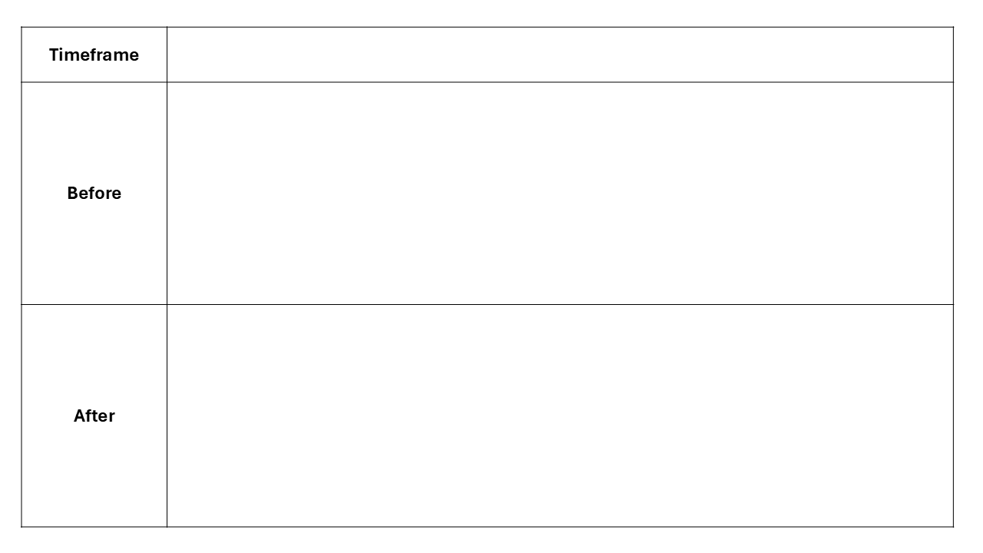
MIT OpenCourseWare
https://ocw.mit.edu/

RES.16-9960 The Engineering Student’s Guide to Effective Technical Communication
Spring 2026

For information about citing these materials or our Terms of Use, visit: https://ocw.mit.edu/terms.

