Practical milestone timelines
A milestone timeline can help you stay organized when it comes to the fellowship application process. Putting in effort up-front to set yourself internal deadlines can help avoid feeling overwhelmed as external deadlines approach.
After an initial read-through of the application requirements, organize the high-level components into a timeline with time on the x-axis and rows corresponding to each application item on the y-axis. An example milestone timeline for the NSF GRFP (11/13/2025 deadline) is provided below:
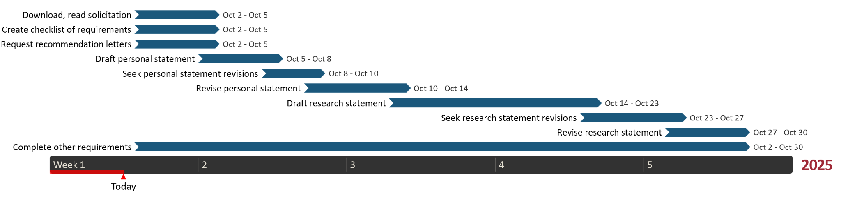
Create your own timeline using the template below.
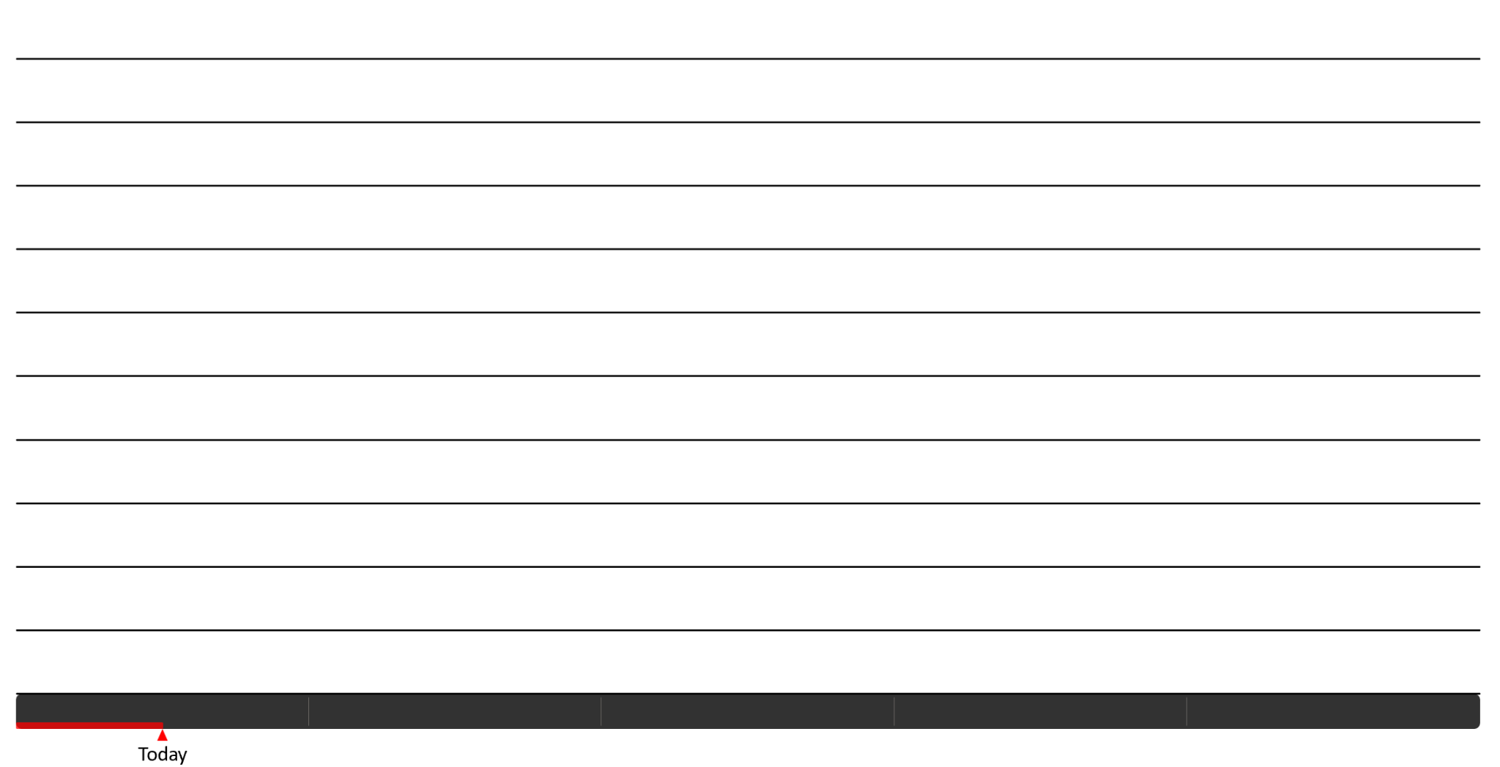

*Remember to account for time buffers for fellowships that require institutional/departmental application submission. Ask your advisor’s financial officer for lead time information.

MIT OpenCourseWare
https://ocw.mit.edu/

RES.16-9960 The Engineering Student’s Guide to Effective Technical Communication
Spring 2026

For information about citing these materials or our Terms of Use, visit: https://ocw.mit.edu/terms.

