Graduate Fellowship Examples
Take a look at this list of popular graduate fellowships and mark the ones you are interested in applying to.

- NSF GRFP (National Science Foundation Graduate Research Fellowship Program)
- NSTGRO (NASA Space Technology Graduate Research Opportunities)
- DoD NDSEG (National Defense Science and Engineering Graduate) Fellowship
- FINESST (Future Investigators in NASA Earth and Space Science and Technology) Program
- MathWorks Fellowship (administered by MIT)
- Hertz Fellowship
- Amelia Earhart Fellowship
- GEM Fellowship
- Other:____________________________________________

— — —

Below is a summary of application requirements for a select few graduate fellowships common in AeroAstro. This is not an exhaustive list – please check the solicitations carefully for all required materials!

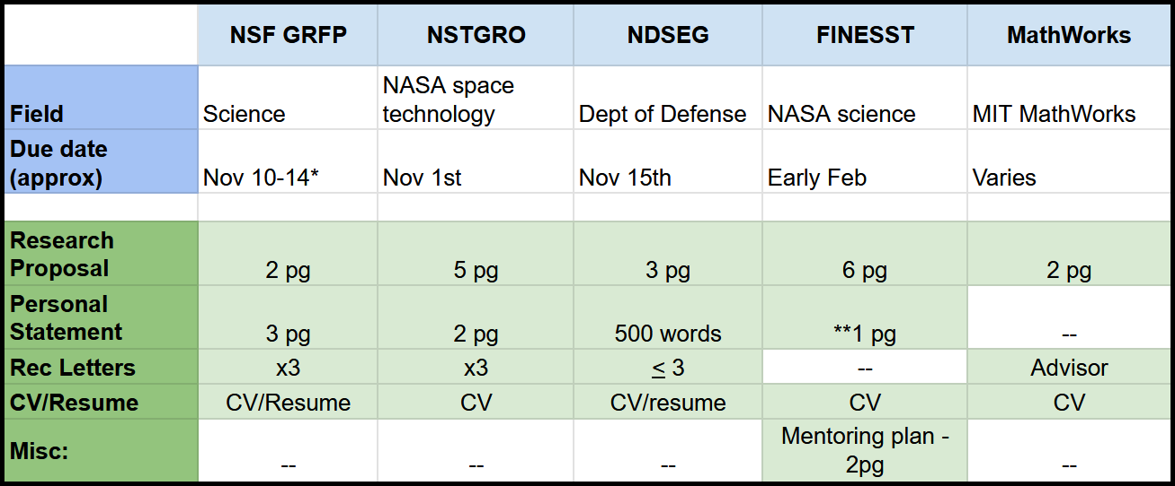

MIT OpenCourseWare
https://ocw.mit.edu/

RES.16-9960 The Engineering Student’s Guide to Effective Technical Communication
Spring 2026

For information about citing these materials or our Terms of Use, visit: https://ocw.mit.edu/terms.

